**Force System Parts**

1. Voltage Switch
2. Latch
3. D-Sub Connectors
4. Ethernet Cable
5. Power Cable
6. D-Sub to CPC Cable

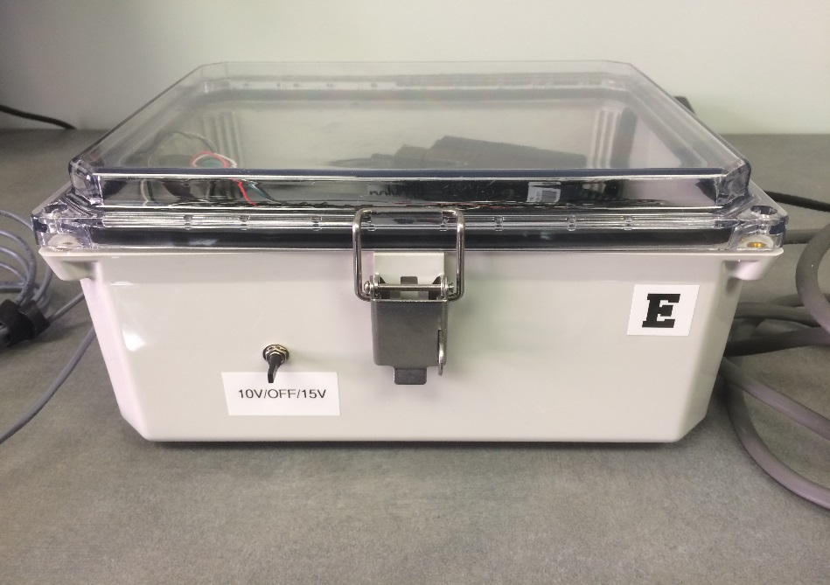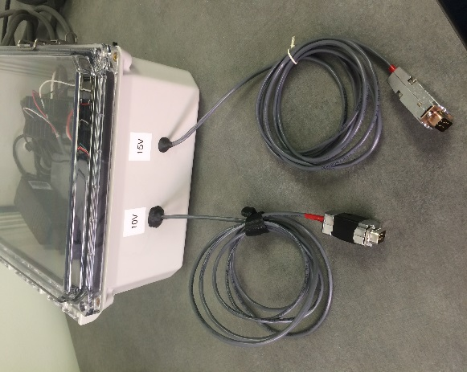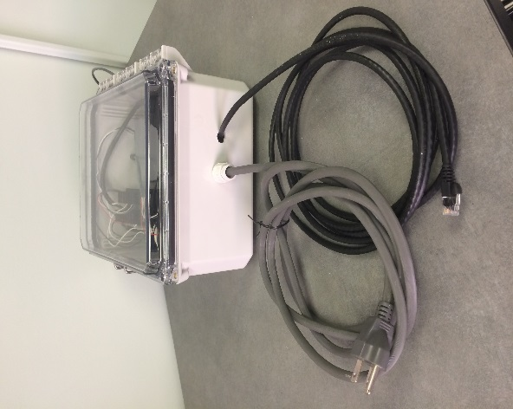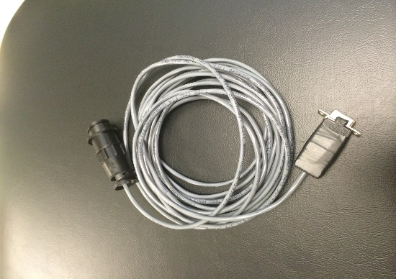

**1**

**3**

**2**

**4**

**5**

**6**

**Force System Set Up**

1. Plug the power cable (4) into the wall.
2. Connect the force box to the transducer (see table for appropriate voltage and connector).
3. If using Ethernet, plug the cable (4) into the NI chassis and the computer. The force box can be opened with the latch (2). If using Wi-Fi, this will be covered later.
4. Flip the voltage switch (1) to the appropriate voltage (same as the d-sub cable used).
5. Turn on the computer and follow the force system instructions.

|  |  |  |  |
| --- | --- | --- | --- |
| Transducer | Exercise Device | Excitation Voltage | Connector |
|  | Force Chair Quad Exercise Device | 10V | D-Sub  Note: This is the only transducer that connects directly to the force box |
|  | MR Quad Exercise Device | 10V | CPC |
|  | Hand Grip | 10V | CPC |
|  | Foot Exercise Device | 15V  Note: Can operate with 10V | CPC |

**Force System Instructions**

**1)** Open NI MAX

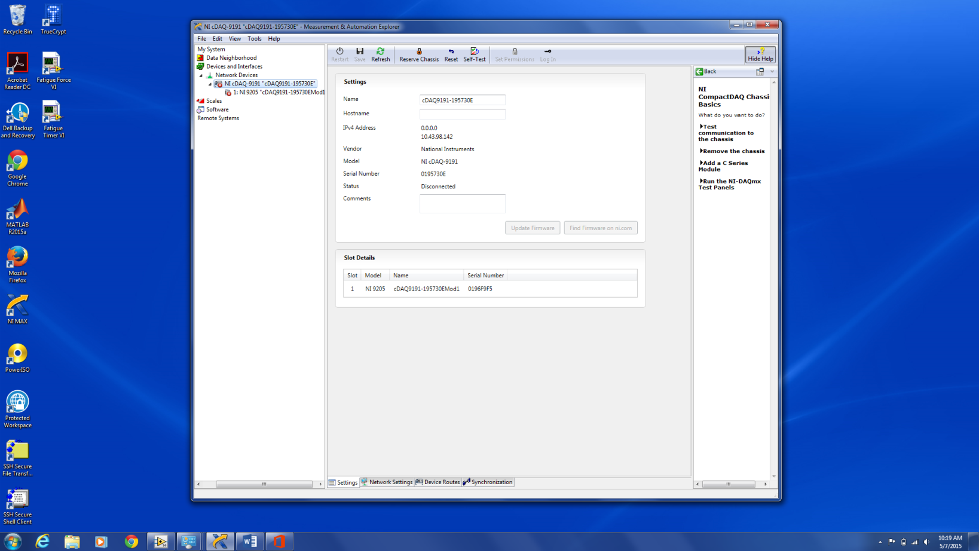

**2)** Click on the “Network Devices” tab on the left.

**3)** You should see “NI cDAQ….” ending with a ‘B’ or and ‘E’ depending on which force box you are using.

**4)** If you see the cDAQ and it is connected, as shown in the bottom figure, continue to step 5. If it is not connected, as shown in the top figure, continue to step 4A.

**4A)** Check for the following:

* The force box is on and connected to the internet
* The laptop is connected to the same network as the force box (usually vummiv)
* The chassis is reserved for the laptop. If it is already reserved for the laptop, the button will say “Unreserve Chassis” as shown in the bottom figure - this is what you want. If it is reserved for another laptop, there will be a button that says, “Reserve Chassis” as shown in the top figure. Click this button and authorize to disconnect the chassis from the other laptop.

**5)** Click the “Self-Test” button at the top of the window to verify the force system is communicating with the laptop. If the status says “Connected – Running”, you should be good to go. (If the volume on the laptop is not muted, you will hear the device connecting to the computer.)

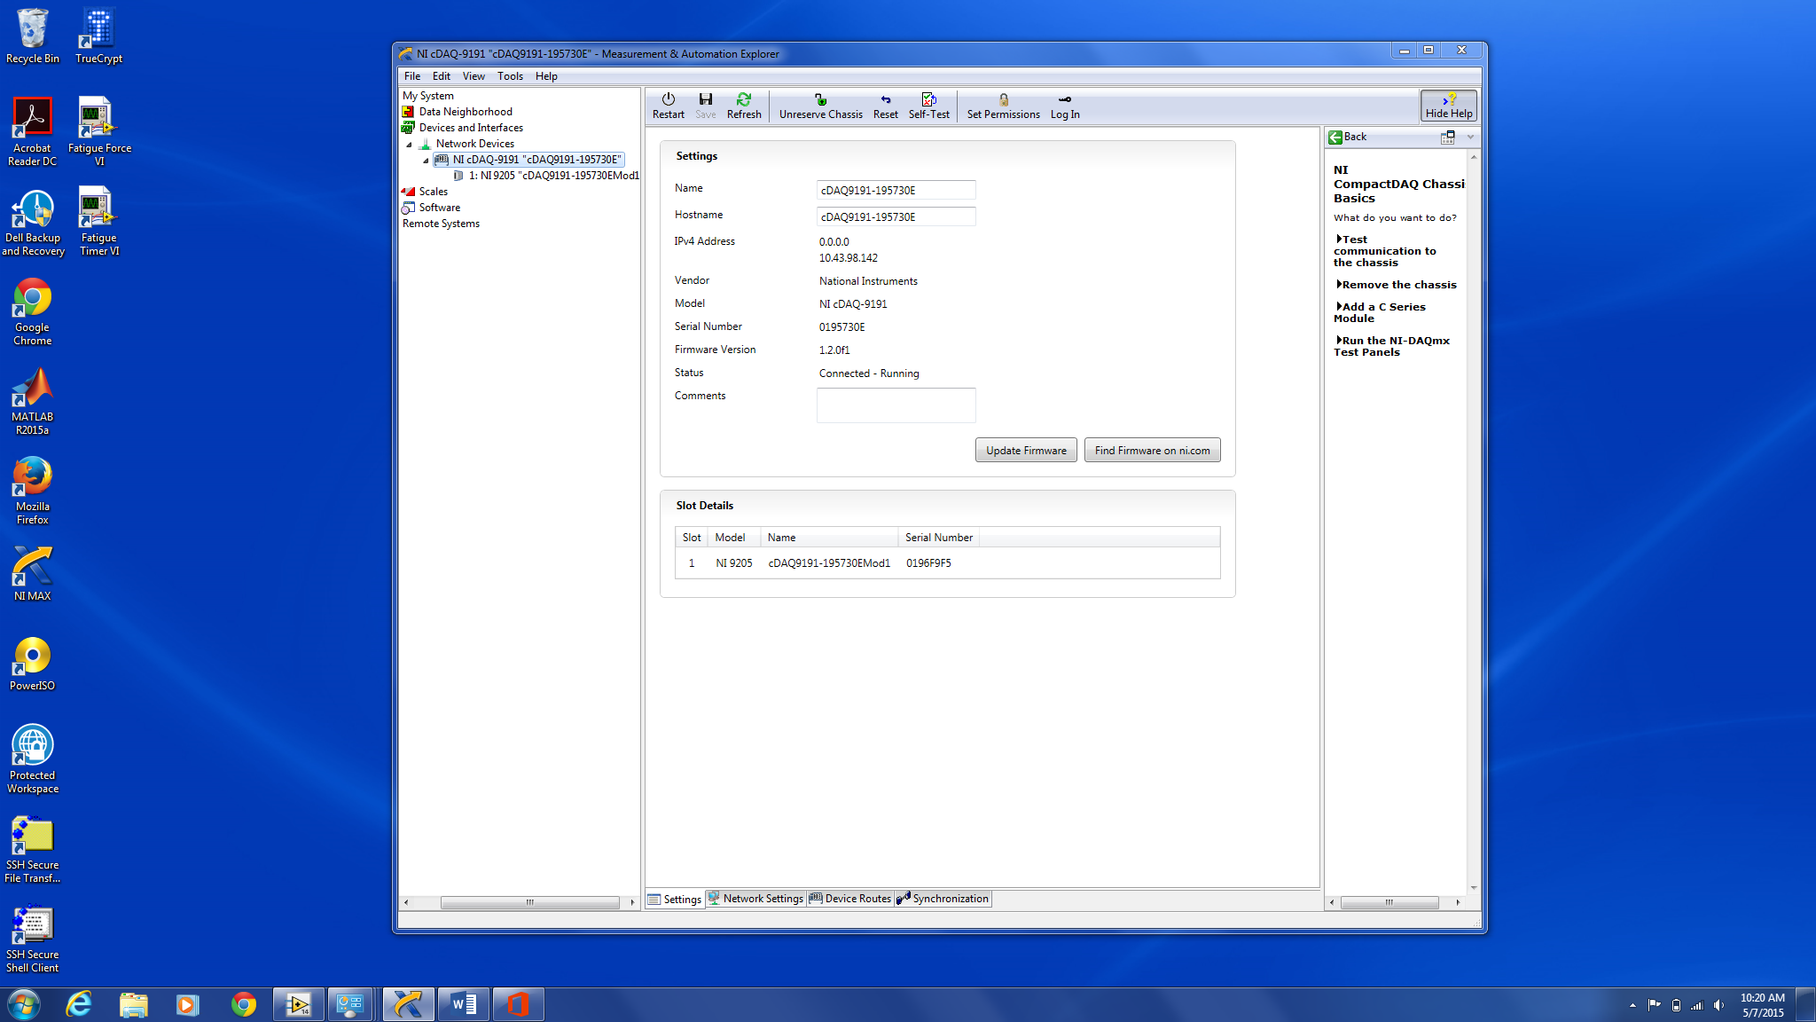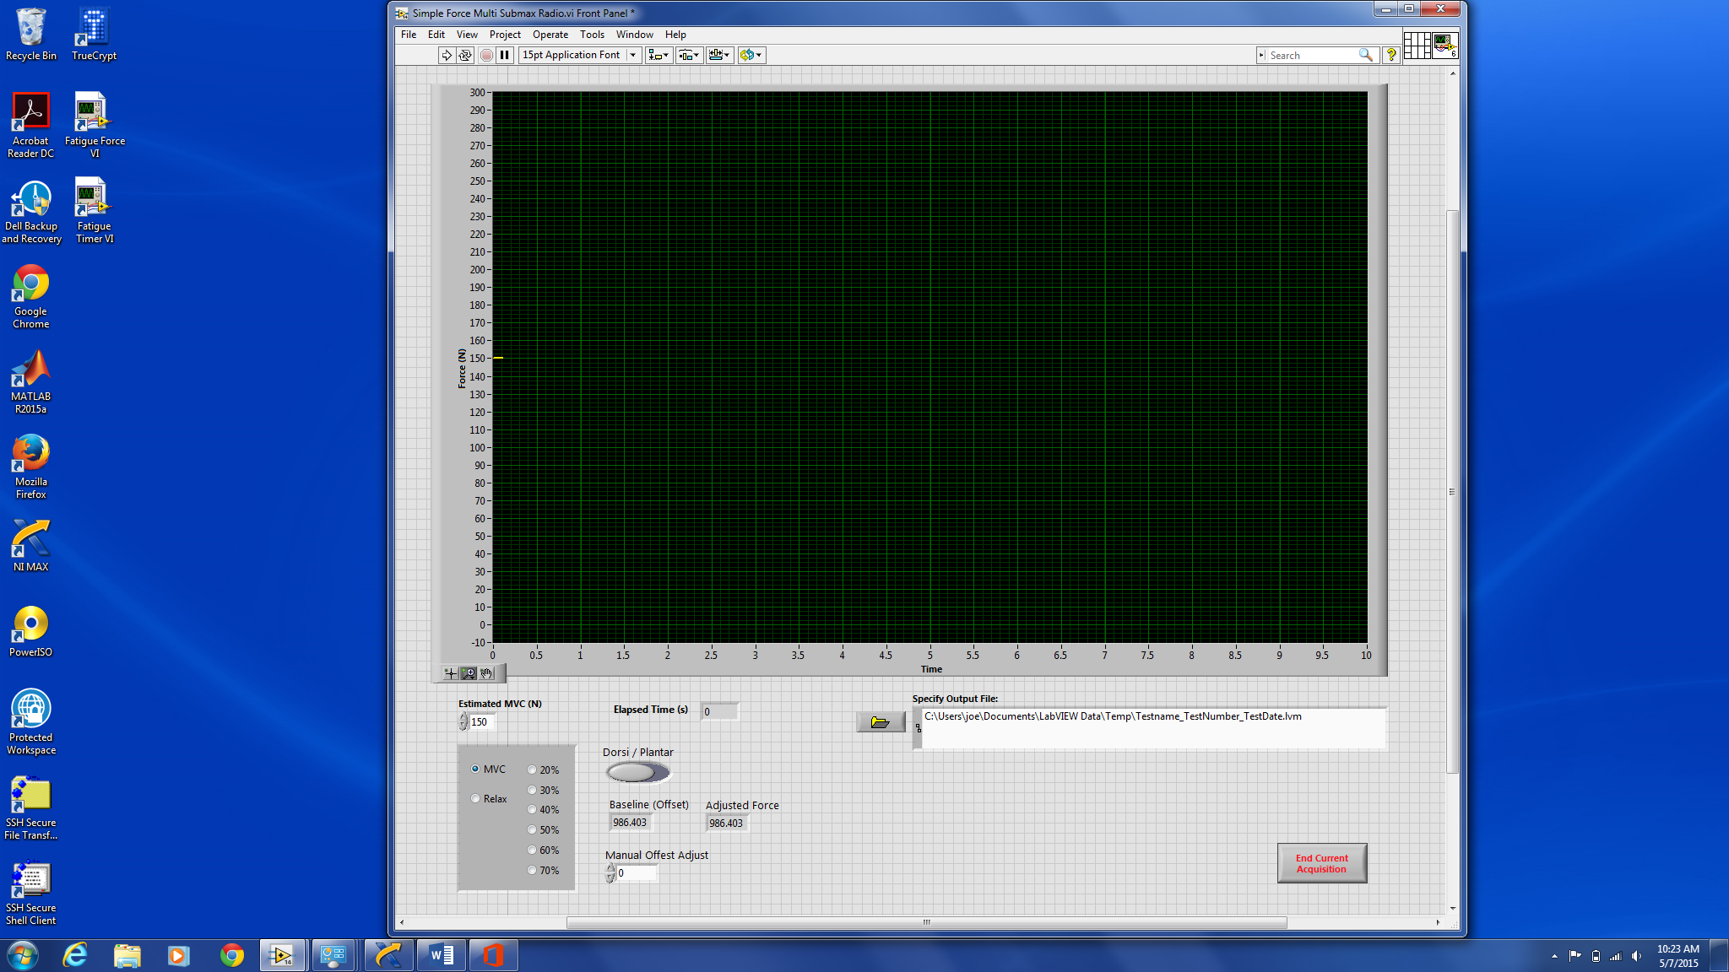

**Enter in MVC here.**

**Radio buttons can be used to quickly switch between MCV, relax, and submax target forces. These are auto calculated based on the input for “Estimated MVC (N)”.**

**While VI is running, enter in value from “Baseline (Offset)” box into “Manual Offset Adjust” box to bring baseline to 0. “Adjusted Force” should then read close to 0.**

**Use to switch between dorsi and plantar**

**Enter output file.**

**\*VI will not run without a valid output file.**

**6)** Open “Fatigue Force VI”. If there is no icon, this file can be found in the following directory: *C:\Users\Public\Documents\LabVIEW Fatigue VIs* and the file name is *“Simple Force Multi Submax Radio”.*



**Click arrow to run VI.**

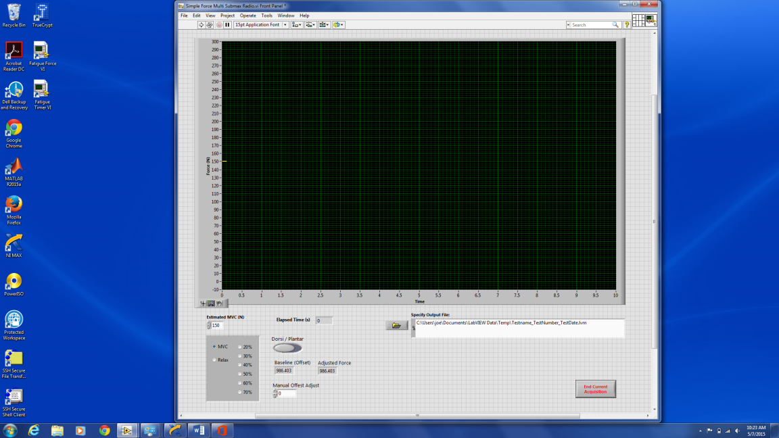

**7)** Enter in an output file.

**8)** Click the arrow to run the VI.

**9)** Use the control panel to adjust the settings as needed.

**If you get the error displayed in the figure…**

**1)** Press “Stop”

**2)** Double click the “DAQ Assistant” which will open up a new window.

**Force System Troubleshooting**

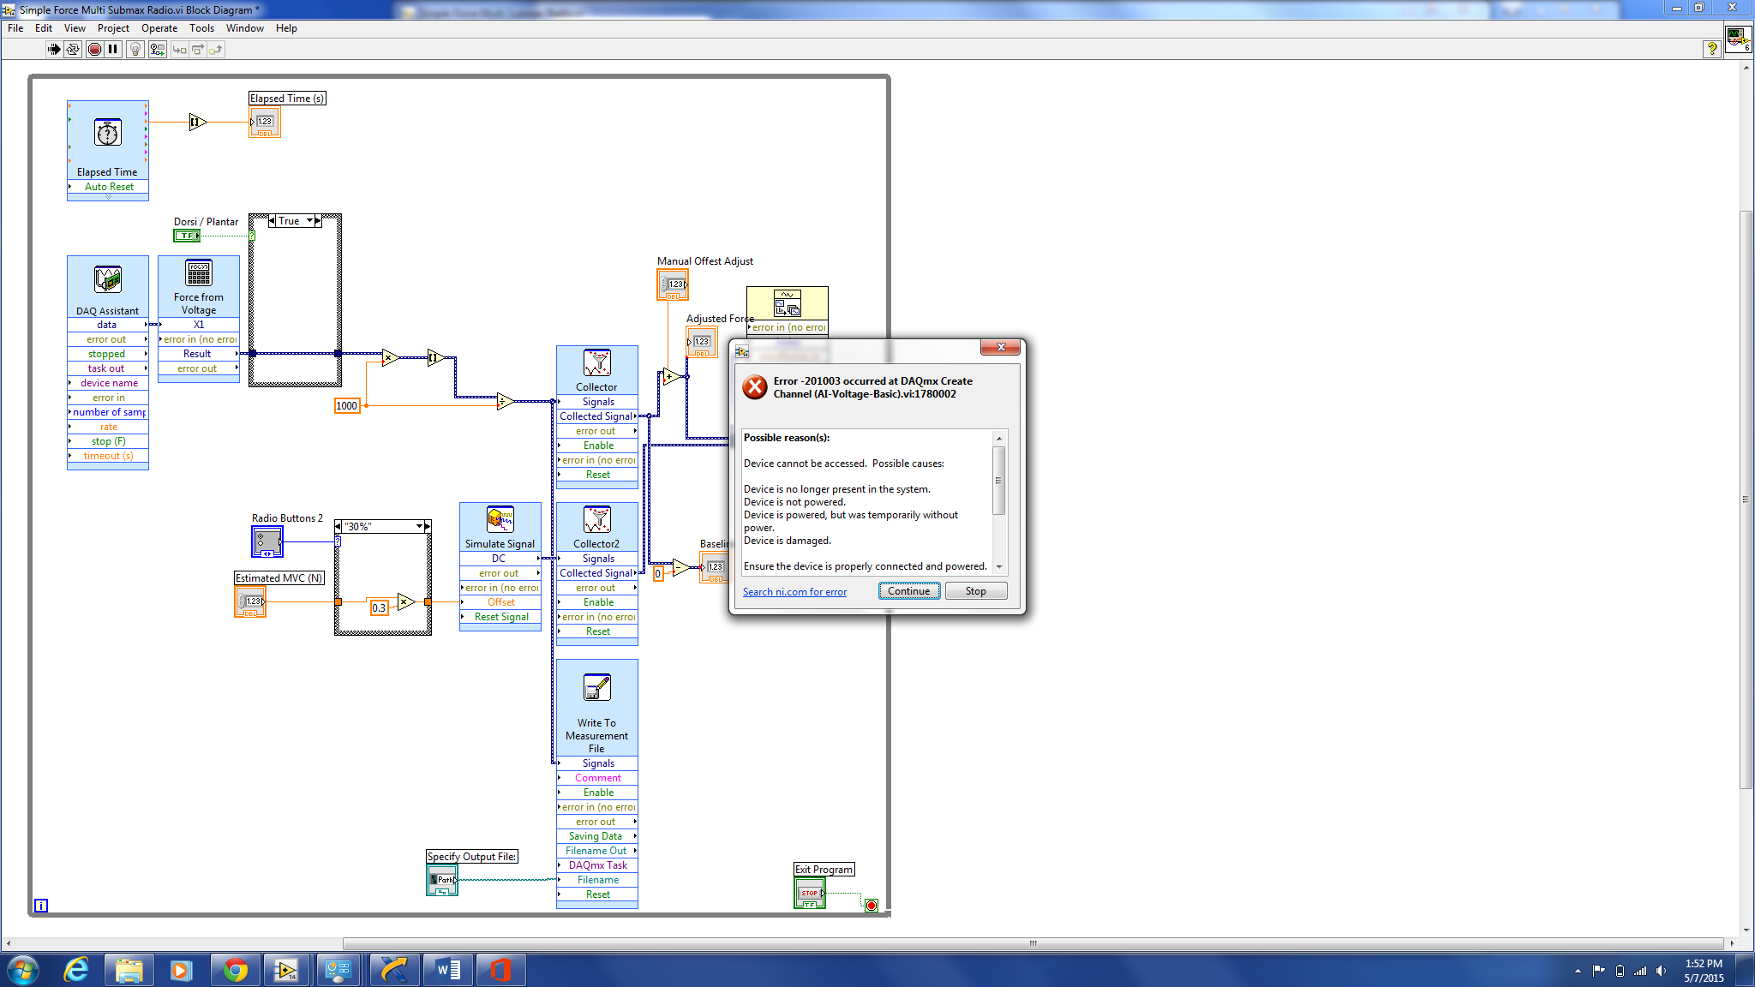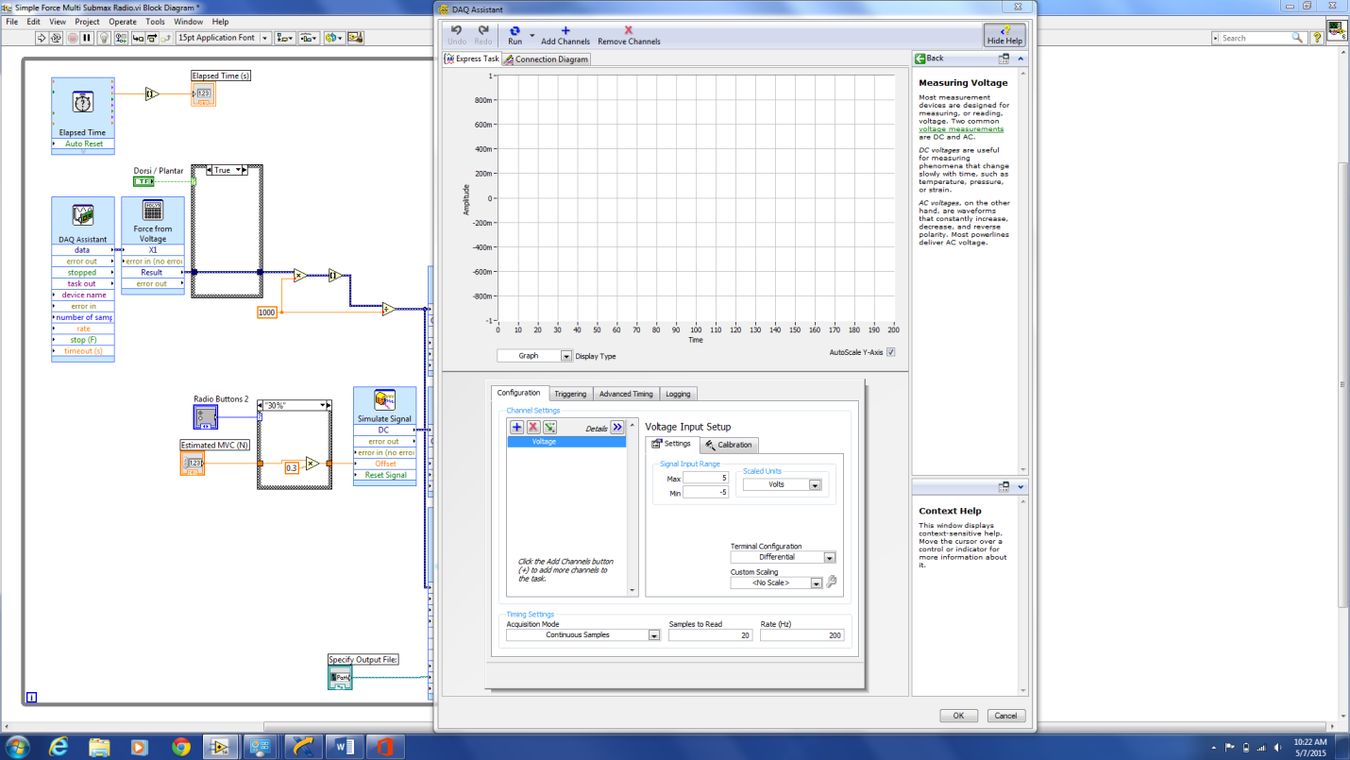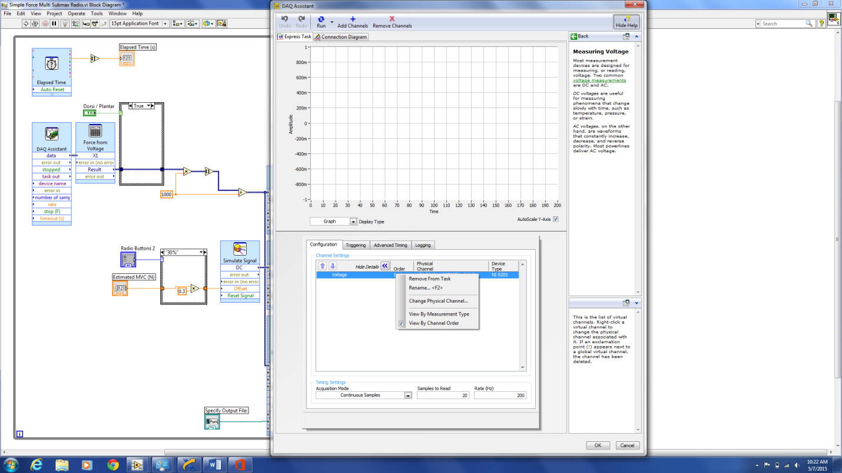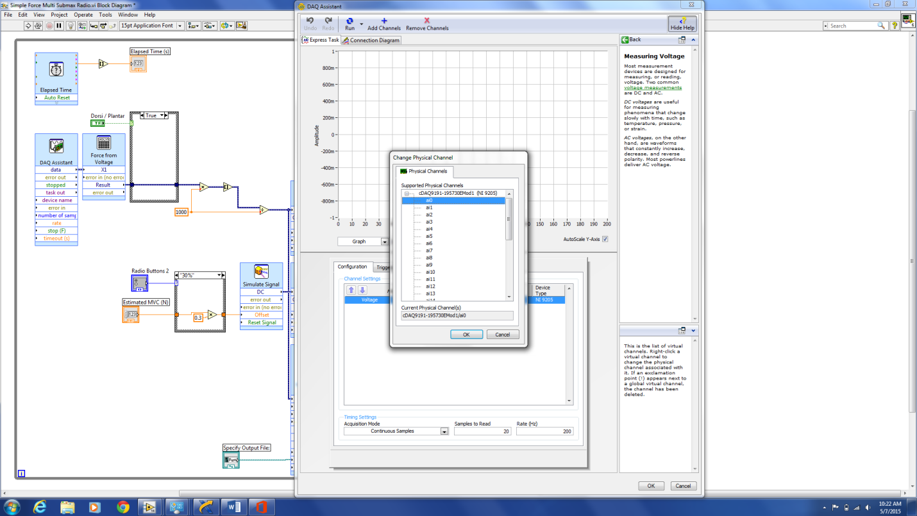

**3)** Right click where it says “Voltage” and select “Change Physical Channel”.

**4)** In the new window, select “a0”. (Tip: if a0 is already selected, highlight a different channel before re-selecting a0.) If this window is not populated, go back to the NI MAX instructions and make sure the device is connected to the laptop.

**5)** Press “OK” in the Physical Channel window and “OK” again in the DAQ Assistant window. A notification should pop up that the force VI is building. Once this is finished you should be good to go.

**If you get a signal of all noise…**

**1)** Check to make sure everything is connected and on. Noisy signals are most often the result of the force box not being turned on or the force transducer not being connected.

**2)** If you are sure everything is turned on and connected correctly and you are still getting a signal of all noise and no error notification from LabView, it is time to start checking the connectors. *This is an unlikely error and a big pain in the magnet, so make sure to double check everything before this step.

**If NI Max notifies you that there is an error with the data dictionary…**

**1)** Reset the program back to configuration defaults. Note: You need admin privileges to be able to do this. If you do not have admin privileges and cannot find anyone who does, go find the other laptop.

**Diagrams and Pin Assignments for Force System Connections**

Pin Assignments for Cable #1 (Force Transducer to Cable #2)

**Round 9 Pin Female Connector**

Pin 1: RED

Pin 4: BLACK

Pin 7: GREEN

Pin 8: WHITE

Pin Assignments for Cable #2 (Cable #1 to Cable #3)

**Round 9 Pin Male Connector**

Pin 1: RED

Pin 4: BLACK

Pin 7: GREEN

Pin 8: WHITE

**DB-9 Female Connector**

Pin 1: RED

Pin 4: BLACK

Pin 5: GROUND

Pin 7: GREEN

Pin 8: WHITE

Pin Assignments for Cable #3 (Cable #2 to Cable #4)

**DB-9 Male Connector**

Pin 1: RED

Pin 4: BLACK

Pin 7: GREEN

Pin 8: WHITE

**DB-25 Female Connector**

Pin 2: BLACK

Pin 4: WHITE

Pin 10: RED

Pin 12: GREEN

Pin Assignments for Cable #4 (Cable #3 to Amplifier)

**DB-25 Male Connector**

Pin 2: BLACK

Pin 4: WHITE

Pin 10: RED

Pin 12: GREEN

**Omega DMD-465WB Amplifier**

Pin 1: RED (Jumped from Pin 2)

Pin 2: RED

Pin 3: BLACK (Jumped from Pin 4)

Pin 4: BLACK

Pin 5: GREEN/YELLOW (from AC)

Pin 6: BLUE (from AC)

Pin 7: BROWN (from AC)

Pin 8: GREEN

Pin 9: WHITE

Pin 10: BLACK (to A/D Converter)

Pin 11: RED (to A/D Converter)

**NI cDAQ-9174 w/module NI 9205**

Pin AI0+: RED

Pin AI8-: BLACK

Pin COM+: GREEN (Jumped to AI8-)

**Diagrams and Pin Assignments for Force System Connections**

Force Box Components:

* DMD-465 Strain Amplifier/Signal Conditioner
* NI cDAQ 9191 CompactDAQ One-Slot Wireless Chassis
* NI 9205 Module
* YH Series Hinged Waterproof NEMA Electrical Enclosure - 10.59 x 8.59 x 5.11 in
* DPDT Center Off Mini Toggle Switch

CPC Connector Components:

